Prague, 3 April 2017

24TH ANNUAL EDITION OF DAYS OF EUROPEAN FILM WILL BE OPENED BY THE MAN WHO DECEIVED THE ENTIRE SPAIN

Prague, 6 – 13 April (Lucerna, Světozor, Royal and Kino Pilotů cinemas)
Brno. 14 – 17 April (Scala cinema)

Echoes will take place in the following towns and on the following dates:
Boskovice (18 – 20 April 2017), Jablonec nad Nisou (18 – 23 April 2017),
Hodonín (18 – 20 April 2017), Semily (18 – 21 April 2017),
Hradec Králové (19 – 21 April 2017), Havířov (20 – 23 April 2017)
____________________________________________________________________________________________________________

OPENING OF DAYS OF EUROPEAN FILM
This year’s Days of European Film will bring about 50 films from different parts of Europe and, like every year, will offer the most interesting films of the current European cinema. The festival will be opened by the Spanish film Smoke & Mirrors by the director Alberto Rodríguez on 6 April. Bribes, star witnesses, secret services and billions in foreign accounts – the largest Spanish corruption scandal of the 1990s and the story of a man who deceived the entire Spain. This suspenseful spy film received a number of awards, including the Silver Shell at the San Sebastián Film Festival for the best acting performance in a leading role for Eduard Fernández and the Feroz Zinemaldia Award for the best film. The Goya Award for the best adapted screenplay should also be mentioned. The producer Francisco Javier Ramos Quiñones will arrive to personally present the film at the opening. He produced the successful and acclaimed film El Método by Marcelo Piñeyra and is now preparing a film by Mateo Gila, the author of screenplays for films such as Vanilla Sky, The Sea Inside, Open Your Eyes or Agora.
Zdeněk Blaha, the festival programmer, comments on this film: “This suspenseful political-spy thriller is an addition to the director’s previous work, particularly the thrillers Unit 7 and Marshland, which attracted huge attention from the audience at DEF last year. The story based on true events shows a big corruption scandal of the 1990s and the related series of frauds and abductions orchestrated by a single person: Francisco Paesa. His part was absolutely excellently played by Eduard Fernández who is well-known in our country, too.”
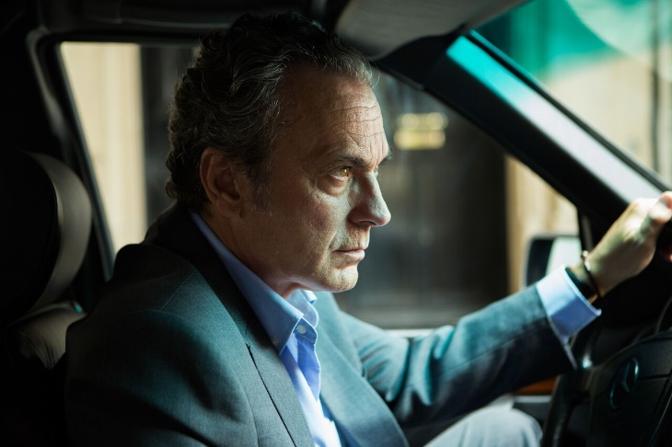
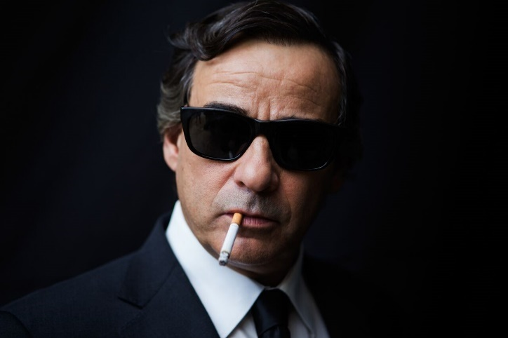
Eduard Fernández as José Coronado in the opening film Smoke & Mirrors
by the director Alberto Rodríguez. Source: DEF

CZECH CO-PRODUCTIONS AND OTHER GUESTS OF THE FESTIVAL
Three films, which were co-produced by Czech producers under a minority co-production scheme, are worth mentioning. DEF will present the opening night of a film titled The Chronicles of Melanie by the screenwriter and director Viesturs Kairišs who will be a guest of the festival along with the Czech producer Julietta Sichel. The film is distributed by Bontonfilm in the Czech Republic. Another film is Ministry of Love by the director Pav Marinković. Together with him, the actor Slobodan Milovanović and the sound engineers Ludvik Bohadlo and Jan Paul will visit the festival in person. In the personal presence of creators, the Czech-Slovak film Little Harbour by Iveta Grófová will also be presented. This film received the Crystal Bear Award at the Berlin International Film Festival, given by a jury composed of children within the Generation Kplus section. The film will be personally presented by Iveta Grófová, the director, and Matěj Hlaváč, the music composer. The films Ministry of Love and Little Harbour are distributed by CinemArt in the Czech Republic. Yallah! Underground, a documentary about an alternative music scene in the Middle East, will be presented by the director Farid Eslam. Distribution in the Czech Republic is carried out by Stray Dogs.
Other guests of the festival include Giancarlo Soldi, an Italian director, will also arrive and personally present his documentary Five Wor(L)ds, which reveals the artistic worlds of five major Italian creators who have all received the golden Oscar statues. The jazz drummer Günter “Baby” Sommer who is the protagonist of the music documentary Als Mensch ein Solist will also make an appearance. The audience can look forward to his concert that will take place in the Royal club on Saturday 8 April.

PROGRAMME SECTIONS

The film festival will present the most interesting works offered by European cinema recently and will screen about 50 European films divided into both traditional and new sections.

Best of / In the selection of the delicacies of European cinema, the audience can look forward to the Greek film Chevalier, directed by Athina Rachel Tsangari. It is a peculiar film written by the most prominent contemporary Greek screenwriter Efthymis Filippou who regularly cooperates with Yorgos Lanthimos (The Lobster, Dogtooth). Another distinctive film in this section is Me and Kaminski, a new film by Wolfgang Becker, the author of Good Bye, Lenin!, once again with Daniel Brühl in the leading role. The last year’s big winner of the Spanish Goya film awards, Truman by the director Cesc Gay, will also be presented. It is an optimistic film about a profound friendship between two men in a difficult situation. DEF will present the opening night of the drama titled Graduation. The film is about compromises, personal morality and the essence of parenthood. Cristian Mungiu received the Best Director award for this film in Cannes in 2016. Aerofilms is distributing this film, which will open in Czech cinemas on the date of its opening night at DEF.

To the Point / A traditional section prepared in cooperation with the Representation of the European Commission in the Czech Republic will focus on children and adolescents this year. What are the European children of today like? How do they think? What do they expect from life? What is troubling them? In his new film Being 17, André Téchiné captures the fragility of growing up by telling a story of two adolescent boys from a small town in France. On the opening day of DEF, the distribution (by Artcam) of the documentary Kinders in the Czech Republic will be launched. This film will give us a look into a musical camp where children open up about the problems that trouble them as well as about their plans and visions for the future in a way that will put a smile on the audience’s faces.

MEDIA – contemporary European animation / The MEDIA section will summarise the forms of the contemporary European animation over several past years. The viewers can look forward not only to older films such as The Illusionist or The Suicide Shop but also to the latest film The Red Turtle. Adults will be able to find something to enjoy such as the animated documentary Crulic – The Path to Beyond and so will the smallest children with films such as Paddington and Shaun the Sheep Movie.

€Docs / At this year’s festival, documentaries fitting for the large screen are represented, among others, by Safari, the latest film by Ulrich Seidl, an Austrian documentarist with a feeling for bizarre situations. The documentary Nice People about the first Somalian national team competing in a Swedish winter sport called bandy, which is similar to ice-hockey, will remind of the legendary Cool Runnings. A film connoisseur should also not miss the film Five Wor(L)ds, in which leading Italian directors Roberto Benigni, Bernardo Bertolucci, Gabriele Salvatores, Paolo Sorrentino and Guiseppe Tornatore speak about their love for film.

Film & Music / The Film & Music section is a special section of this year’s annual edition of the festival. Besides documentaries, it will also include Sing Street, a new musical film by John Carney, which is a comedy about growing up in Dublin in the 1980s, and a French co-produced film As I Open My Eyes by Leyla Bouzid who captures the dark period in Tunisia shortly before the revolution, which came with the Arab Spring, in a story of a young female singer.

LUX Film Prize / This year, too, there will be a presentation of the finalists of the European Parliament LUX Film Prize, including the absolute winner, the German bitter comedy Toni Erdmann.

SPECIAL EVENTS

Film Flavour / Thursday 13 April 2017 and Saturday 15 April 2017 at 19:00, Royal cinema, Vinohradská 48, Praha 2.

Days of European Film and recognised Prague chefs bring screenings inspired by the Cinema Cuisine trend in the special section called Film Flavour. The concept of Cinema Cuisine consists in combining the screening of a film and a culinary experience. On the unique premises of Royal cinema, a pop-up restaurant will be set up and its menu will correspond to the theme and settings of the film. The price of 500 CZK per person includes a delicious three-course menu, wine, water and a film.

LIKE CRAZY
AND THE COLORFUL ITALIAN MENU
Thursday 13 April 2017, 19:00, Royal cinema.

The unique experience of cinema cuisine will be brought to you by the Italian chef Alex Facchin.

https://www.facebook.com/events/1132452630217831/

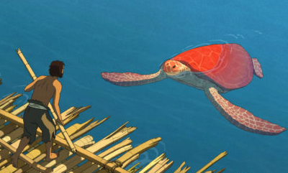
THE RED TURTLE
AND THE SWEET FRENCH MENU
Saturday 15 April 2017, 19:00, Royal cinema.

The three-course- menu will be prepared by Mohammed Saouchi, aka „Momo“, the chef of the French bistro Café 35.

https://www.facebook.com/events/384588061934177/

Film & Jazz / Saturday 8 April 2017, 19:00, Royal cinema.

The programme combining a film and musical experience is one of the main representatives of the Film & Music festival section. A price of 300 CZK per person includes the screening of the film Als Mensch ein Solist about the legendary jazz musician Günter Baby Sommer, his concert, wine and water.
https://www.facebook.com/events/1672624906367450/

Animation workshop for children / Monday 10 April 2017 from 9:00, Kino Pilotů; entry fee is 70 CZK.

Song of the Sea / A gorgeously animated world of Celtic mythology and potent narrative about the power of love between mother and siblings has caused the director to be compared to the masters of animated film and earned him his second Oscar nomination. Director: Tomm Moore / Ireland, 2014 / 93 minutes / Czech dubbing

Animation workshop for adults / Monday 10 April 2017 from 13:30, Lucerna – Big Hall; entry fee is 110 CZK; discount for senior citizens is 55 CZK.

The Red Turtle / A magical motion picture without words, understandable to all generations across all continents received the Prix Spécial in the Un Certain Regard category of the Cannes Film Festival and was the Japanese cult studio Ghibli’s first European co-production. Director: Michaël Dudok de Wit / France, 2016 / 80 min / animated film / silent film

The screening of the two films will be followed by an animation workshop. Animation is as old as the mankind itself. Even prehistoric people tried to paint the walls of their caves, capturing the movement of a mammoth by drawing it with eight feet. How does animation work? Can we make our own moving pictures at home? What would we need to do so? All these questions will be answered by experts from the Free Cinema training and talent platform. A visitor can try out everything by himself/herself.

Screening for schools / Friday 7 April 2017 from 9:00, Lucerna – Big Hall; entry fee is 60 CZK.

Kinders / This documentary follows several children and teens from various family backgrounds and cultures as they encounter life’s difficult, confusing, joyful, even bitter moments. They are all part of the ((superar)) educational music programme, which helps turn social outsiders into young, self-confident people who, through music, learn to recognise their own hidden potential. An enjoyable documentary about children, their daily struggles and their journey to adulthood. Directors: Arash T. Riahi, Arman T. Riahi / Austria, 2016 / 95 min / documentary / German with Czech subtitles. Short animated films will be screened before the film to support the learning of the German language.

Evropský dům cinema / Monday 10 April 2017 at 19:00, Evropský dům, Jungmannova 24, Praha 1. The screening is for free.

Train to Adulthood / Far from the turmoil of modern Hungary, three youngsters work on the Budapest Children’s Railway. The train becomes a metaphor for discussing modern-day Hungary, and offers insights into the thoughts and feelings of the young generation who will soon be responsible for the fate of all of us.
Cinema 2017 / Seminar for cinema exhibitors and film professionals, Wednesday 12 April 2017, 9:00-12:30, Hotel Luna, Kouty 77, 584 01, Ledeč nad Sázavou.
Organised by: Creative Europe Desk - MEDIA, Digitální kino, APK and Days of European Film. Different options of financial support for cinema houses from the Czech Cinematography Fund, the Czech Ministry of Culture or the Creative Europe - MEDIA programme will be presented during the seminar. New projects for making film projects accessible to deaf or blind audience will be presented.
Film markets and co-production forums / A panel discussion for film professionals, Monday 10 April 2017, 9:30-13:00, French Institute in Prague, Štěpánská 35.
Organised by: Creative Europe Desk – MEDIA and Days of European Film. The goal of this panel discussion is to support filmmakers in their international ambitions and to raise awareness about the markets and co-production forums as such. Besides presentations and appropriate strategies for submitting film projects, the panel discussion will include important personal experience of Czech producers with selected markets and evaluation of such markets. Catherine Buresi will be the main guest and she will present the principles of appropriate strategies for international markets. Catherine Buresi has been working in European and international film industry with a focus on festivals, markets and co-production for more than 20 years.

The price of the tickets to DEF screenings in Prague and Brno is 110 CZK. The ticket price of 55 CZK + a screening for senior citizens at Lucerna have been prepared for senior citizens. Tickets to all films can be purchased online. Tickets can also be booked over the telephone or by e-mail. You can find all the information on the programme, its changes, ticket prices, etc., on our website.

The DEF catalogue is available in all cinemas and from partners of the festival for free.

Marija Petrinjac and Hana Kovačević are the authors of the concept, graphic design and jingle of the 24th annual edition of DEF. This year, we drew inspiration for the visual design of the graphic aspects of the festival from the towns hosting DEF. We express our thanks to the towns and their residents for this in a colourful and playful manner.

In keeping with tradition, Lukáš Rumlena (Cabaret Caligula, www.kabaretcaligula.com) will host the ceremonial opening.

The audience can find the detailed DEF programme for each town, the list and descriptions of sections, a catalogue for download, news, information on ticket sale, information on special events, etc., at www.dnyevropskehofilmu.cz and on the FB page of the 24th Days of European Film.

The accreditation form for journalists is available for download at www.eurofilmfest.cz/akreditace. Please, send the filled-out forms by e-mail to michaela.hof@centrum.cz no later than by Tuesday, 4 April. Accreditations will then be ready to be collected in person on Thursday, 6 April from 16:30 to 18:00 at the box office of Světozor cinema or individually as agreed.

“Either you love European film or you do not know it properly. Come to get to know European filmmakers through the selection of the best that they have made in recent years.”
Your Days of European Film

THE FESTIVAL TAKES PLACE UNDER THE AUSPICES OF THE CZECH CULTURE MINISTER DANIEL HERMAN, THE REPRESENTATION OF THE EUROPEAN COMMISSION IN THE CZECH REPUBLIC, ADRIANA KRNÁČOVÁ – THE LORD MAYOR OF THE CAPITAL CITY OF PRAGUE, AND OLDŘICH LOMECKÝ – THE MAYOR OF THE CITY DISTRICT OF PRAGUE 1 / ORGANISED BY THE EMBASSIES AND CULTURAL INSTITUTES OF EUROPEAN COUNTRIES AND BY THE REPRESENTATION OF THE EUROPEAN COMMISSION IN THE CZECH REPUBLIC / WITH THE SUPPORT OF THE MINISTRY OF CULTURE OF THE CZECH REPUBLIC, THE STATE CINEMATOGRAPHY FUND, THE CAPITAL CITY OF PRAGUE, THE INFORMATION OFFICE OF THE EUROPEAN PARLIAMENT IN THE CZECH REPUBLIC AND THE CITY DISTRICT OF PRAGUE 1

THE MAIN PARTNER IS THE AXOCOM MEDIA COMPANY/ THE MAIN MEDIA PARTNER IS THE CZECH TELEVISION / THE MEDIA PARTNERS ARE TÝDEN, INSTINKT, ČSFD.CZ, JOJ CINEMA, EXPRES FM, MŇAM TV, EXPATS.CZ AND PROTIŠEDI.CZ

Contact:
Michaela Dvořáková, PR DEF
Tel.: +420 732 372 424
E-mail: michaela.hof@centrum.cz
Web: www.dnyevropskehofilmu.cz

