Prague, 7 March 2017

24TH ANNUAL EDITION OF DAYS OF EUROPEAN FILM OPENS IN ONE MONTH

Prague, April 6 – 13 (Lucerna, Světozor, Royal and Kino Pilotů cinemas)
Brno, April 14 – 17 (Scala cinema)

Echoes will take place in the following towns and on following dates:
Boskovice (April 18 – 20), Jablonec nad Nisou (April 18 – 23), Hodonín (April 18 – 20), Semily (April 18 – 21), Hradec Králové (April 19 – 21), Havířov (April 20 – 23)
____________________________________________________________________________________________________________
This year’s Days of European Film festival will bring about fifty films from various parts of Europe and just as every year, it will offer the most interesting films of contemporary European cinema. Besides traditional programme sections such as Best Of, €Docs or To the point, which will deal with the topic of children and adolescents this year, the audience can also look forward to an interesting accompanying programme. Film-culinary experiences will also be available in the Film Flavour section. We will offer the flavours of the French and Italian cuisines with the films The Red Turtle and Like Crazy. The festival will also be infused with the rhythm of music. Among other things, the Film&Music section will offer a concert by Günter “Baby” Sommer, a German jazz drummer, along with the documentary about him, called Als Mensch ein Solist. The director Farid Eslad will present his documentary Yallah! Underground for the first time. This film, co-produced with Czech producers, will show the alternative music scene in Middle East. The Days of European Film will also offer an industry programme for cinema operators, producers and others.
The festival will be opened by the Spanish film Smoke & Mirrors by Alberto Rodríguez on 6 April. Bribes, target witnesses, secret services and billions in foreign accounts – the largest Spanish corruption scandal of the 1990s and the story of a man who deceived the entire Spain. It is a thrilling spy movie, which received a number of awards, particularly in recognition of the lead role acting, or most recently the Goya Award for the Best Adapted Scrip.

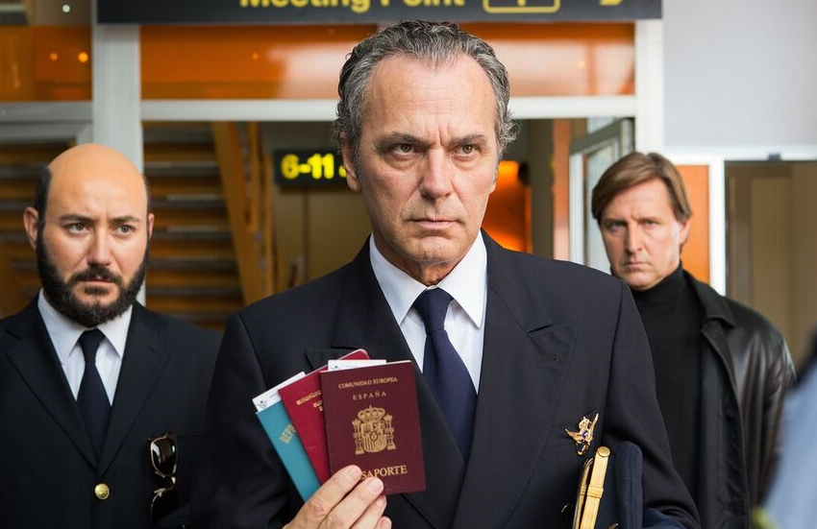
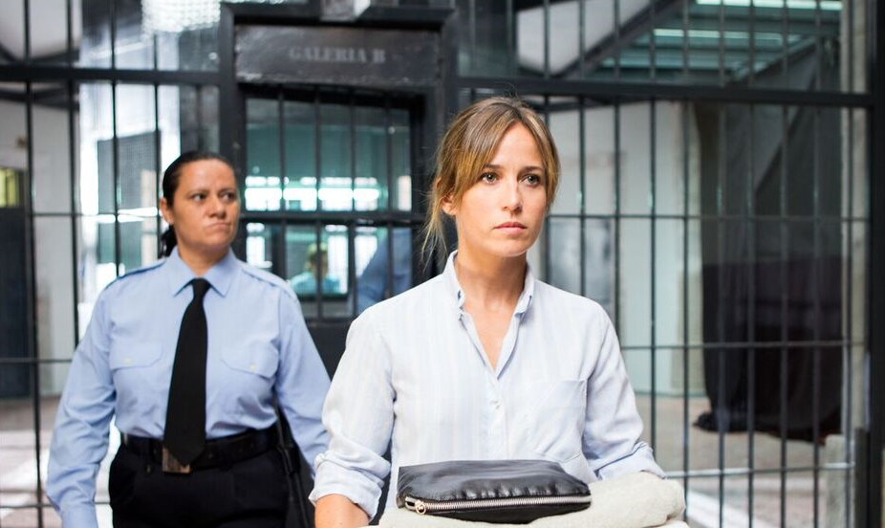
José Coronado and Marta Etura (in the foreground) as representatives of the opening film
Smoke & Mirrors by the director Albert Rodríguez. Source: DEF
Zdeněk Blaha, the festival programmer, comments on this film: “I am very happy that we will open with the new film by Alberto Rodríguez this year. This nail-biting political spy thriller is an addition to his previous work, particularly the thrillers Unit 7 and Marshland, which attracted huge attention from the audience at the DEF last year. The story based on true events shows a big corruption scandal of the 1990s and the related series of frauds and abductions orchestrated by a single person: Francisco Paesa. His part was absolutely excellently played by Eduard Fernández who is well-known in our country, too.”
Three films, which were co-produced by Czech producers under a minority co-production scheme, are worth mentioning. DEF will present the opening night of a film titled The Chronicles of Melanie by the screenwriter and director Viesturs Kairišs who will be a guest of the festival along with the Czech producer Julietta Sichel. Another film is Ministry of Love by the director Pav Marinković. Together with him, the actor Slobodan Milovanović and the sound engineers Ludvik Bohadlo and Jan Paul will visit the festival in person. In the personal presence of creators, the Czech-Slovak film Little Harbour by Iveta Grófová will also be presented. This film received the Crystal Bear Award at the Berlin International Film Festival, granted by a jury composed of children within the Generation Kplus section.
We are still negotiating about the presence of other creators and delegations for films. The specific names of guests who will be present at the ceremonial opening and at each screening will be revealed at the press conference. The audience can find more detailed information on the programme, the list of films in each section and more at www.dnyevropskehofilmu.cz and FB DEF.

We also cordially invite you to a press conference that will take place in the Riding Hall (Konírna) of the Nostic Palace on Monday, April 3, 2017 from 2.00 p.m. (the Ministry of Culture, Maltézské náměstí 1, Prague 1). You can find more information in the attached invitation card. We will provide you with information on the presence of guests from among creators at the press conference sufficiently in advance.

____________________________________________________________________________________________________________

THE FESTIVAL TAKES PLACE UNDER THE AUSPICES OF THE CZECH CULTURE MINISTER DANIEL HERMAN, THE REPRESENTATION OF THE EUROPEAN COMMISSION IN THE CZECH REPUBLIC, ADRIANA KRNÁČOVÁ – THE LORD MAYOR OF THE CAPITAL CITY OF PRAGUE, AND OLDŘICH LOMECKÝ – THE MAYOR OF THE CITY DISTRICT OF PRAGUE 1 / ORGANISED BY THE EMBASSIES AND CULTURAL INSTITUTES OF EUROPEAN COUNTRIES AND BY THE REPRESENTATION OF THE EUROPEAN COMMISSION IN THE CZECH REPUBLIC / WITH THE SUPPORT OF THE MINISTRY OF CULTURE OF THE CZECH REPUBLIC, THE STATE CINEMATOGRAPHY FUND, THE CAPITAL CITY OF PRAGUE, THE INFORMATION OFFICE OF THE EUROPEAN PARLIAMENT IN THE CZECH REPUBLIC AND THE CITY DISTRICT OF PRAGUE 1

THE MAIN PARTNER IS THE AXOCOM MEDIA COMPANY/ THE MAIN MEDIA PARTNER IS THE CZECH TELEVISION / THE MEDIA PARTNERS ARE TÝDEN, INSTINKT, ČSFD.CZ, JOJ CINEMA, EXPRES FM, MŇAM TV, EXPATS.CZ AND PROTIŠEDI.CZ
Contact:
Michaela Dvořáková, PR DEF
Tel.: +420 732 372 424
E-mail: michaela.hof@centrum.cz
Web: www.eurofilmfest.cz.cz

